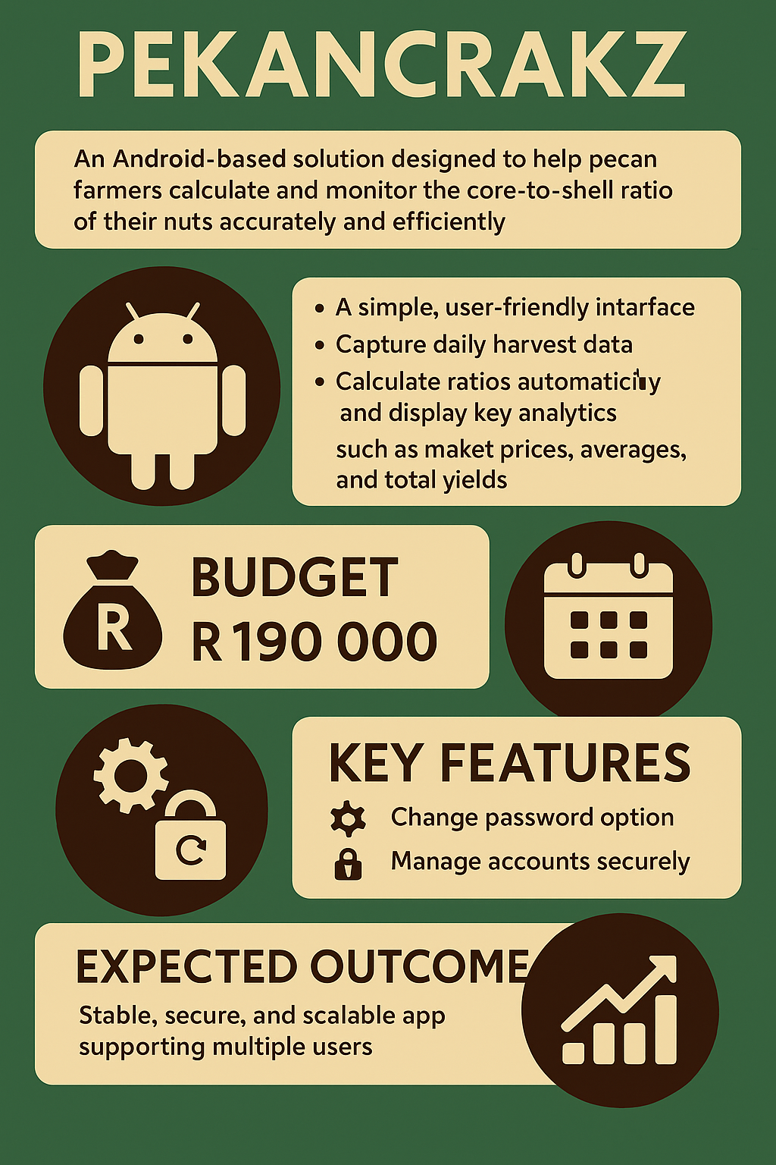

Ashiv: WHO ARE WE

Ashiv: **BACKGROUND OF THE APPLICATION**

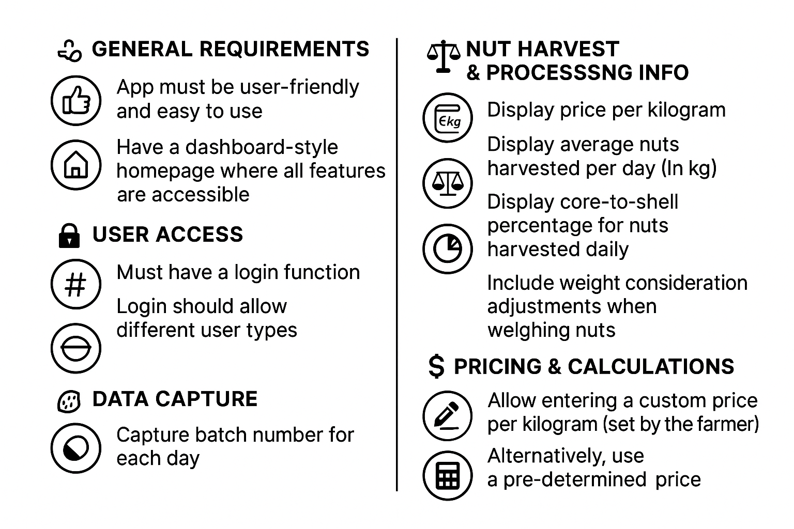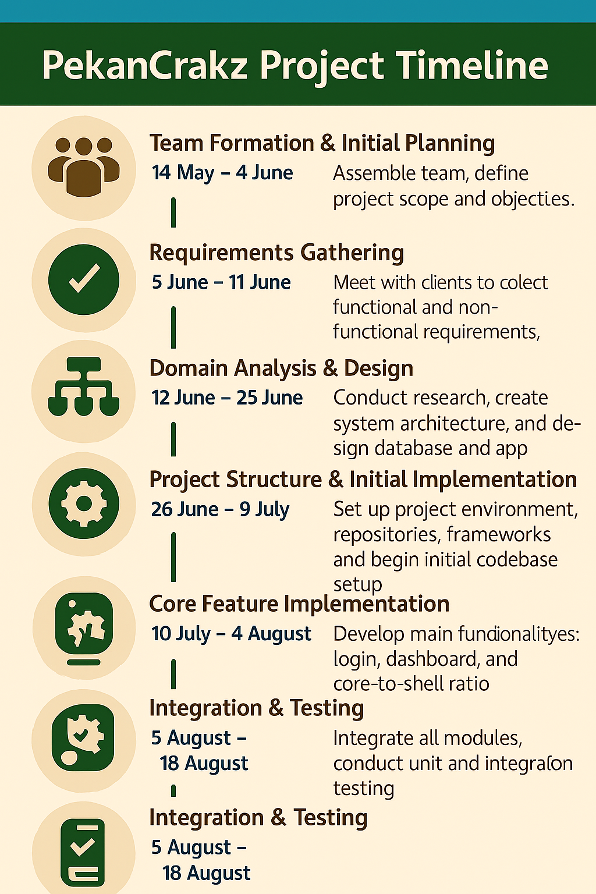

Ashiv: **Cost breakdown**

Krisha: **Project deliverables**

Ashiv: **Target market**

Bermon: **Project overview**

